Accessibility and Structure

Primary Section
Descriptive link:
Open Synthetic Knowledge Base
Generic link:
Click here

Deliberate Jump Heading
Image with meaningful caption below:
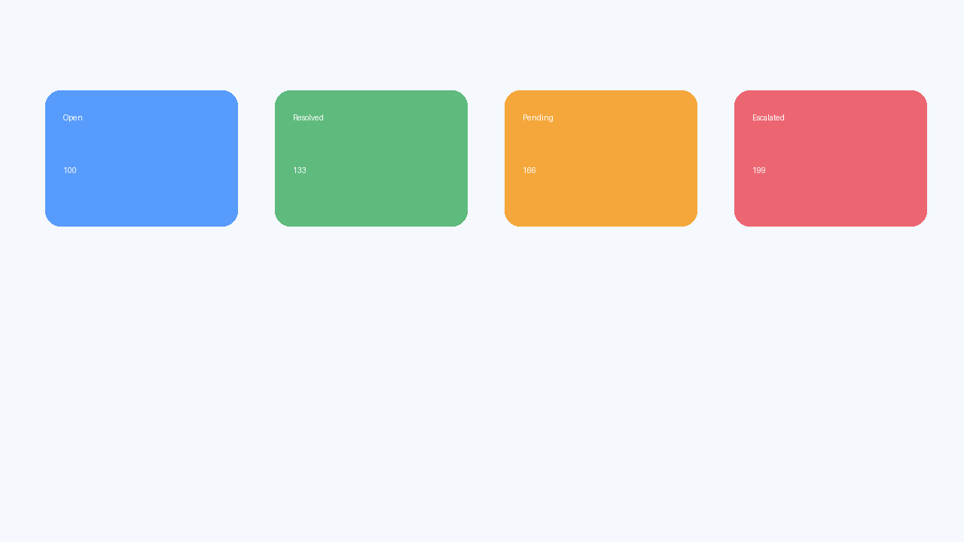
Figure: Status cards by queue state
Image without caption below:


